**Week7**

**PORTFOLIO**

**Assessment Weightage & Type:**

**60% Portfolio Coursework**

**Year:2024**

* Student Name: Pratha Sharma
* UWE ID: 24030176
* Module code: **UFCFL1-15-0**
* Level: **Level 3)**
* Faculty: **Faculty of Internet & Technology**
* Department: **FET Department of Computer Science & Creative**

**Technology**

**Week 7:**

**Exercise-1**

Create a new web page and create a Form with following form controls.

Code:

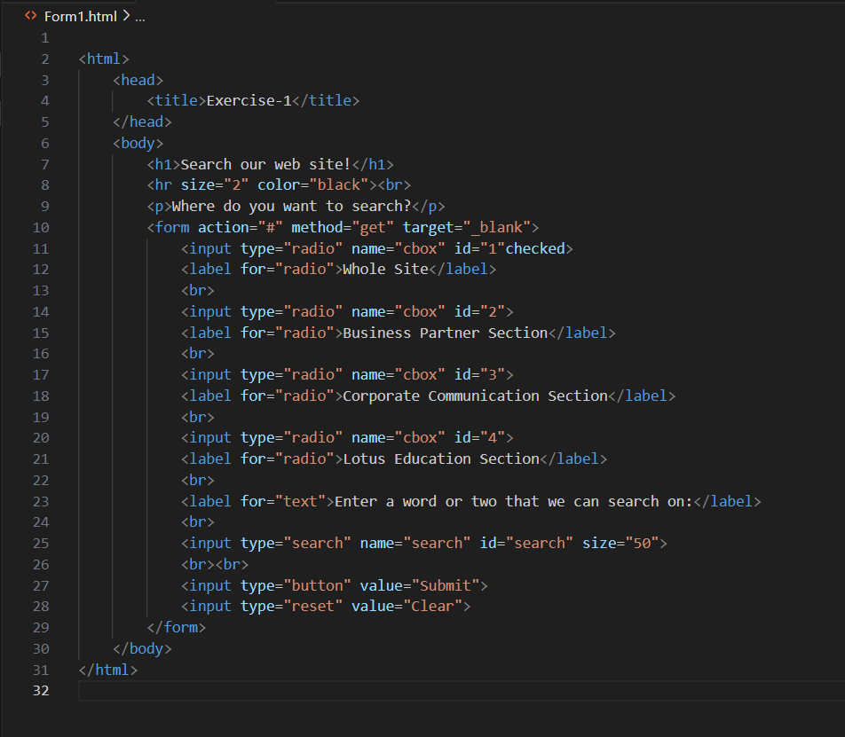

Website:

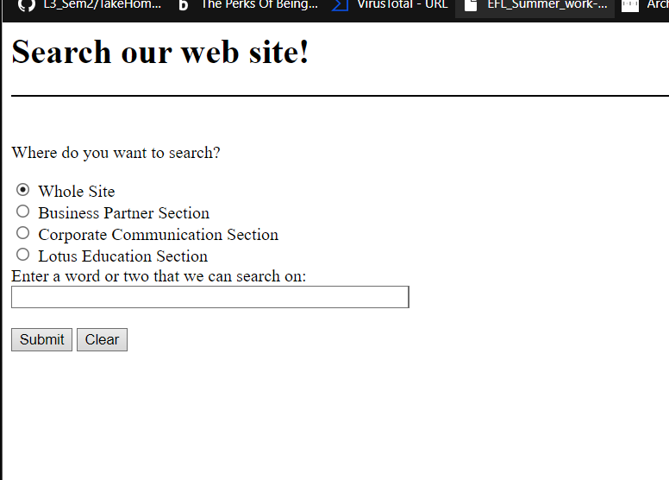

**Exercise 2**

Create a new web page and create a Form with following form controls. [ Hint: Make use

of TABLE].

Code:

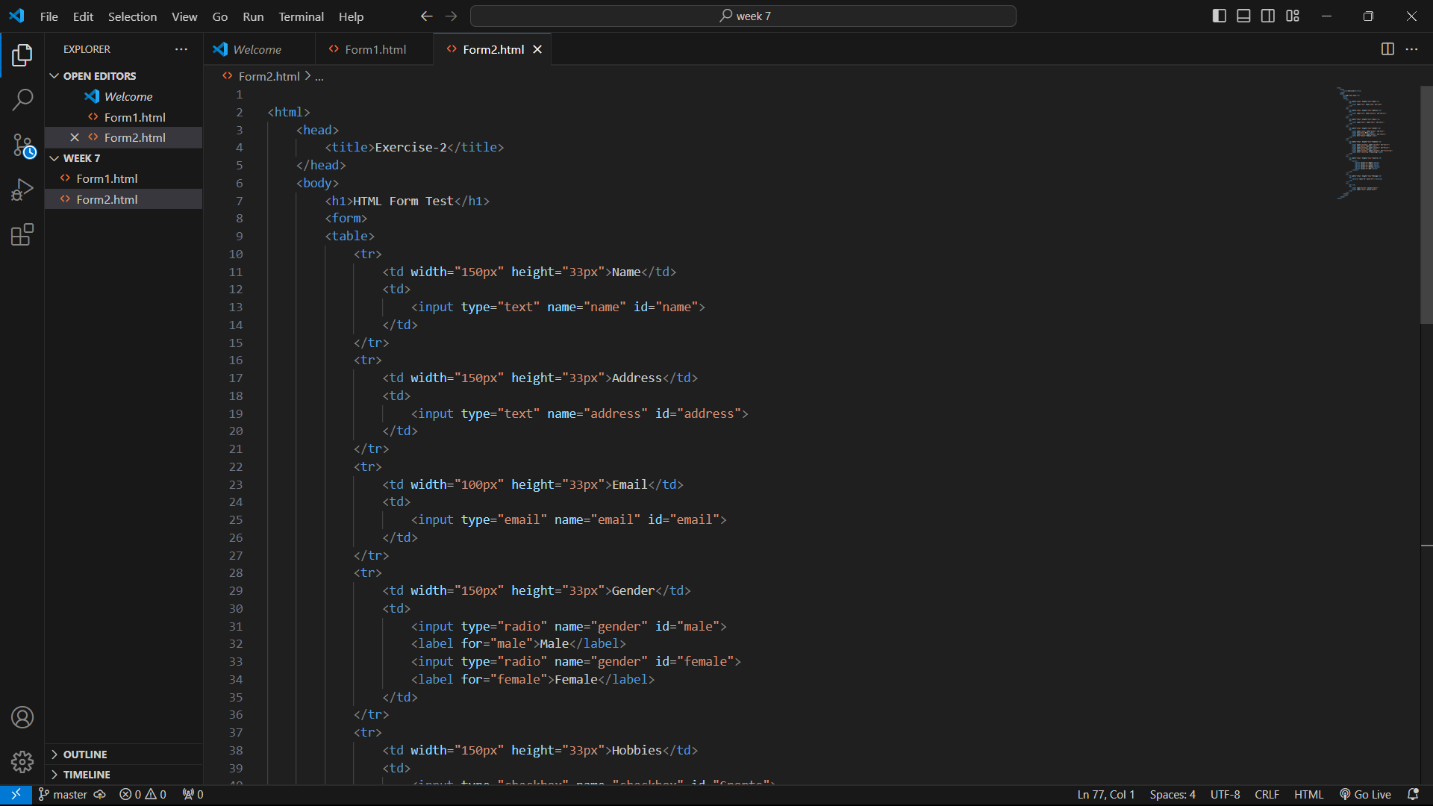

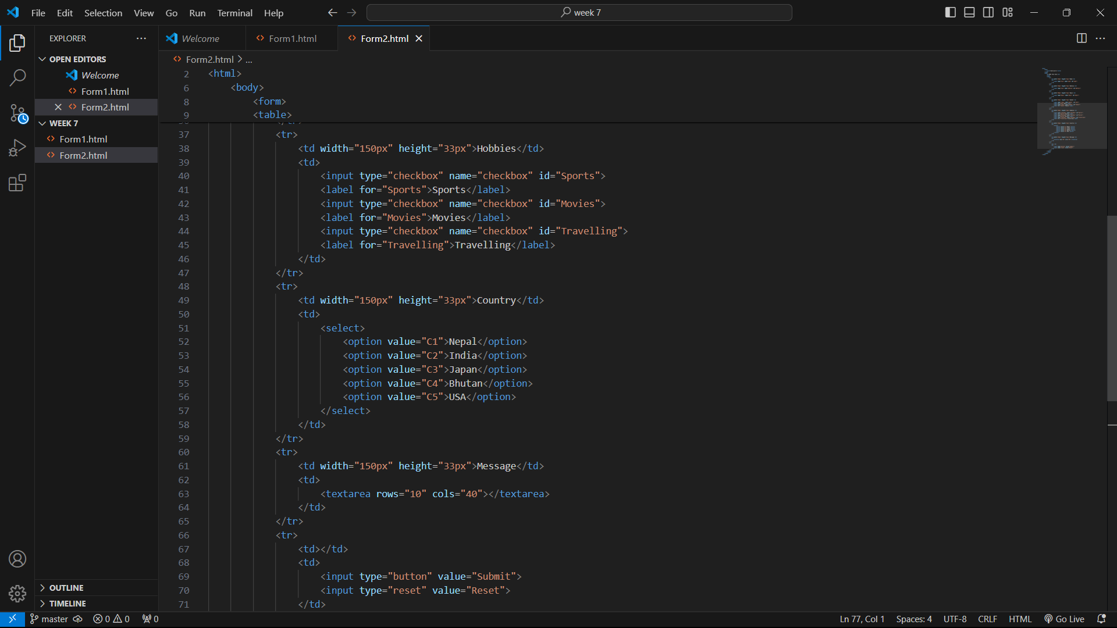

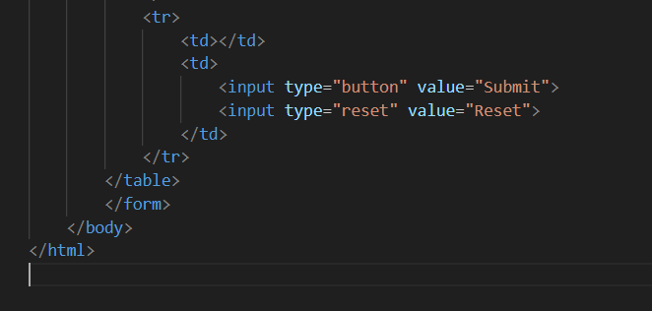

Website:ss

